Redo simulations for old parameterization with CM throughout and 3 EIRs
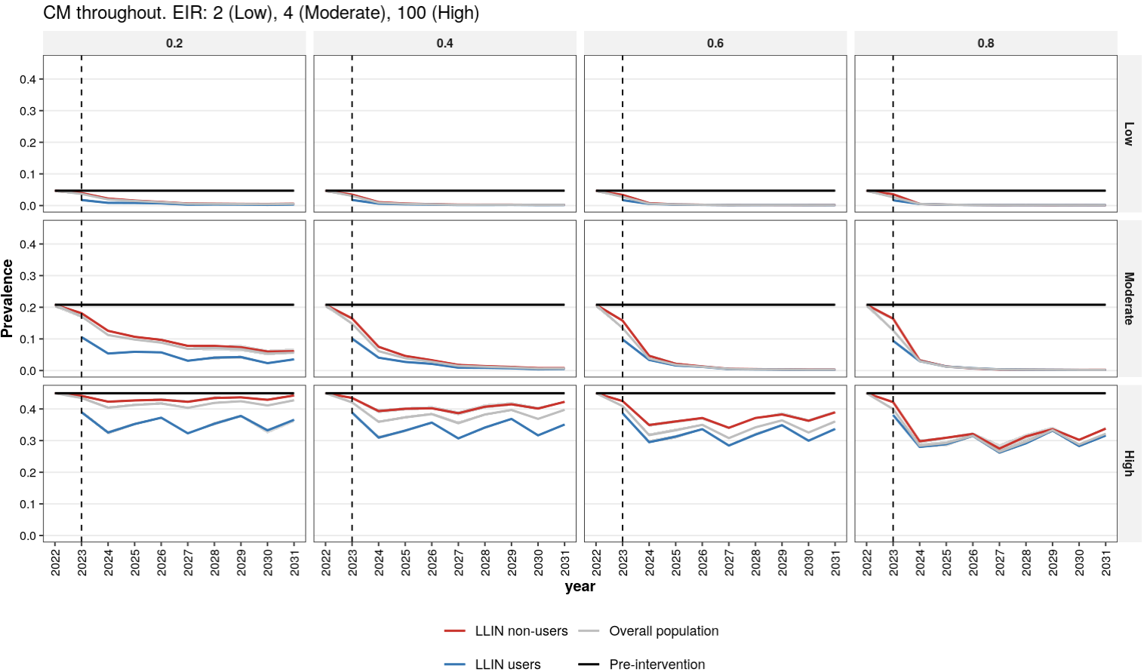

Figure 1 – drivers: CM throughout – three EIRs
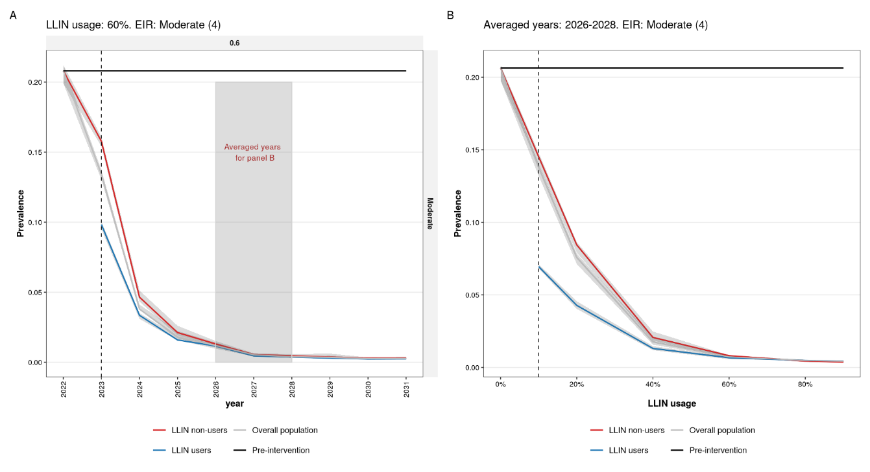
Figure 1 – drivers: CM ends in 2022 – averaged EIRs
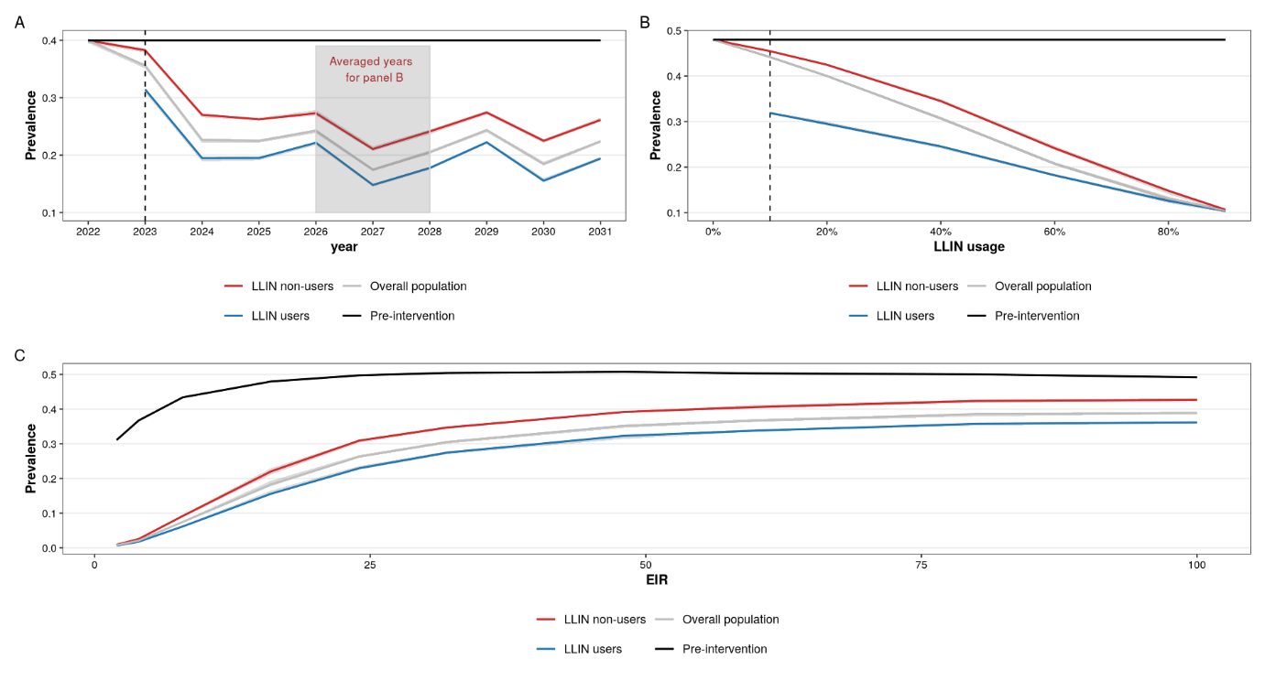

Fig 2 – comparison: CM throughout – three EIRs
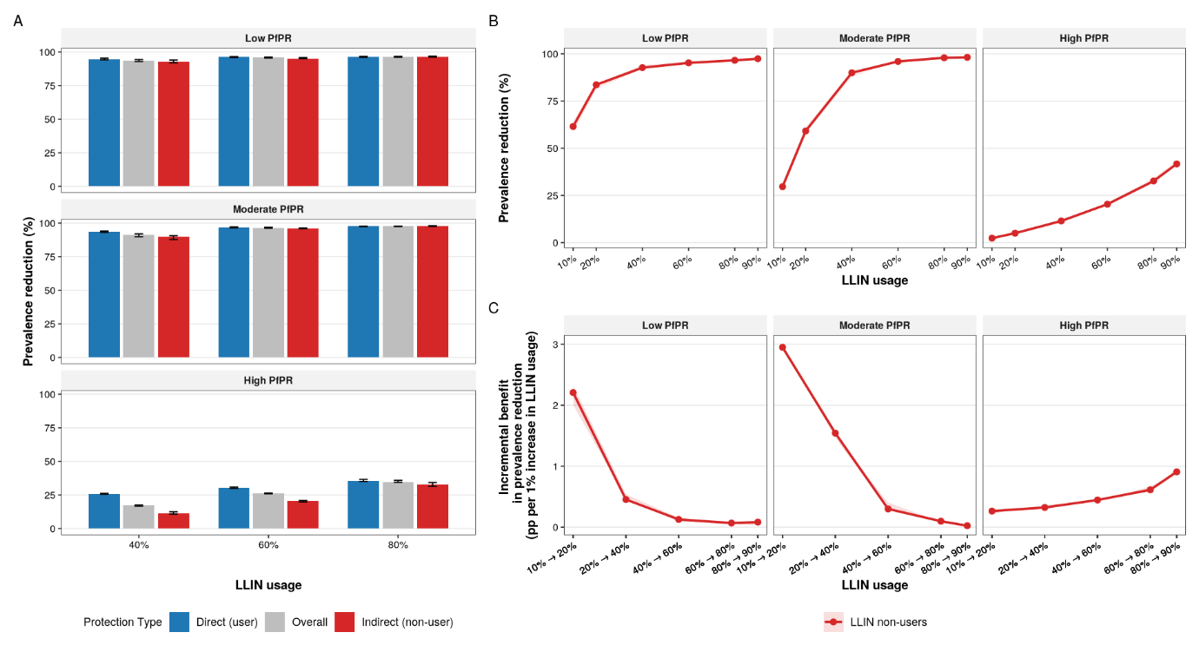

Fig 2 – comparison: CM ends in 2022 – averaged EIRs
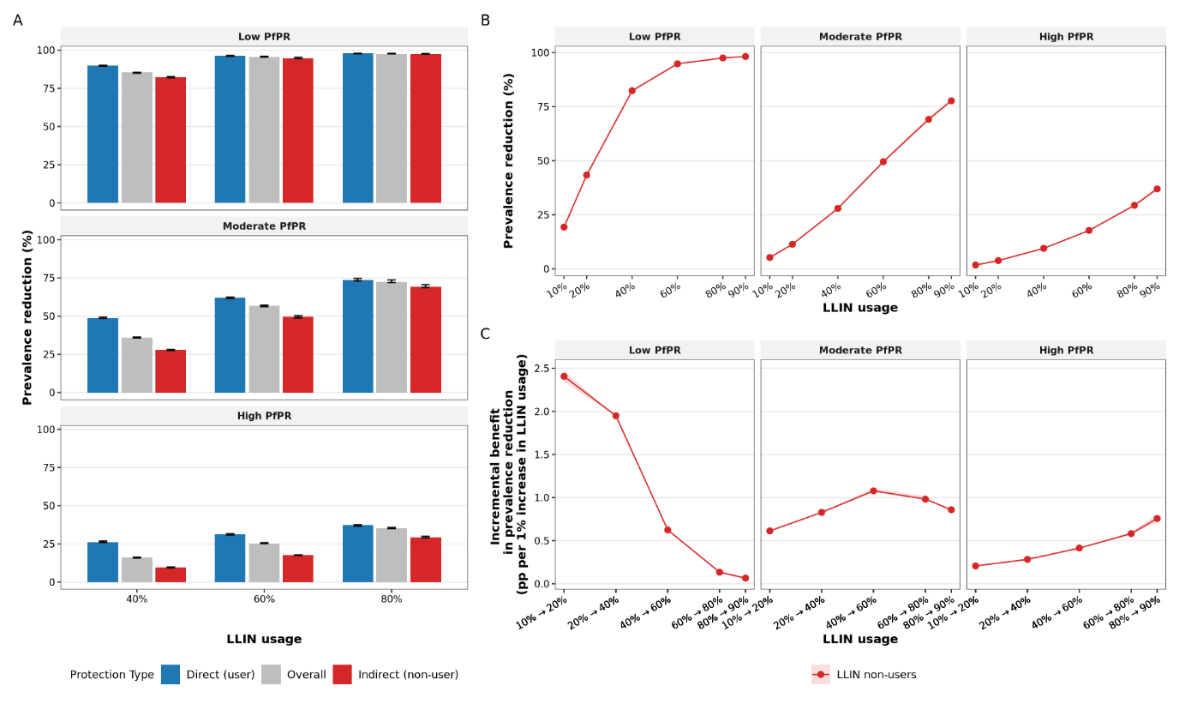

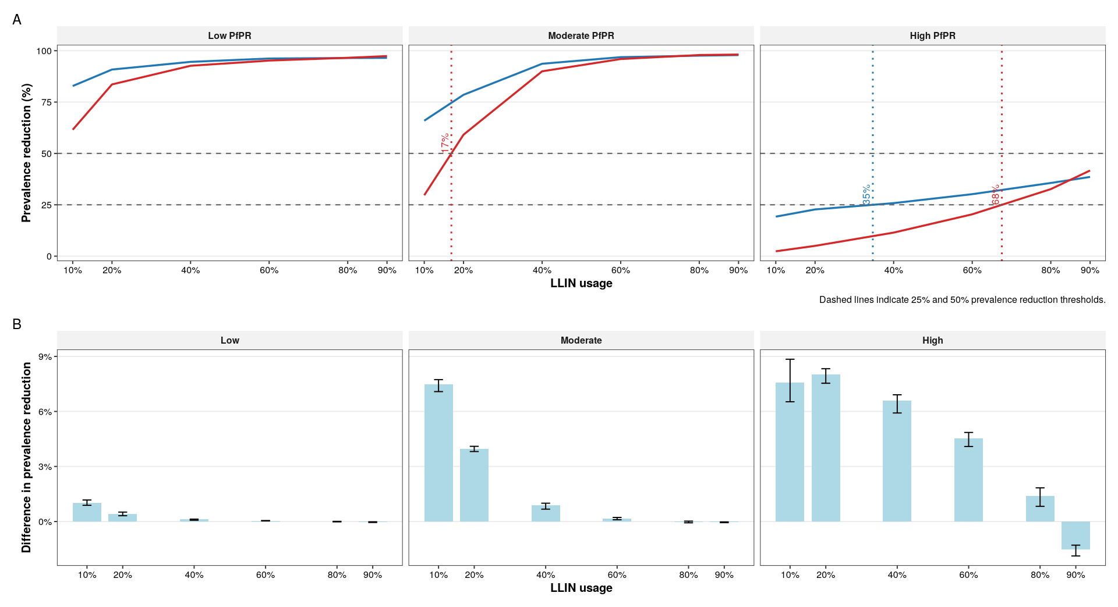

Old param with popsize = 50k, 3 EIRs (2,4 100)
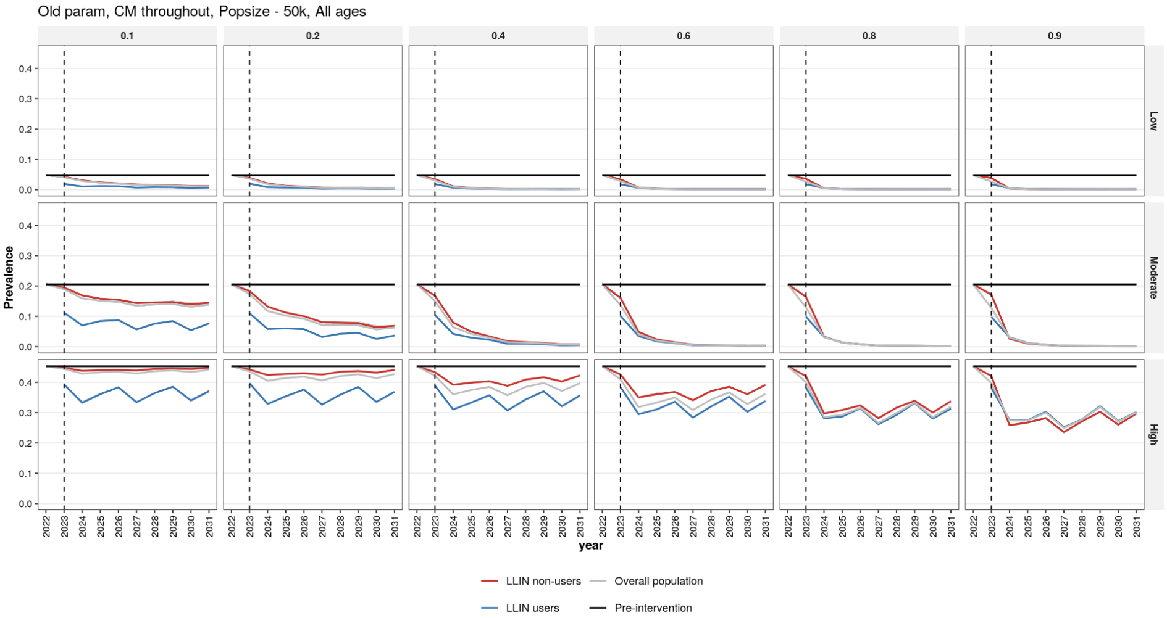

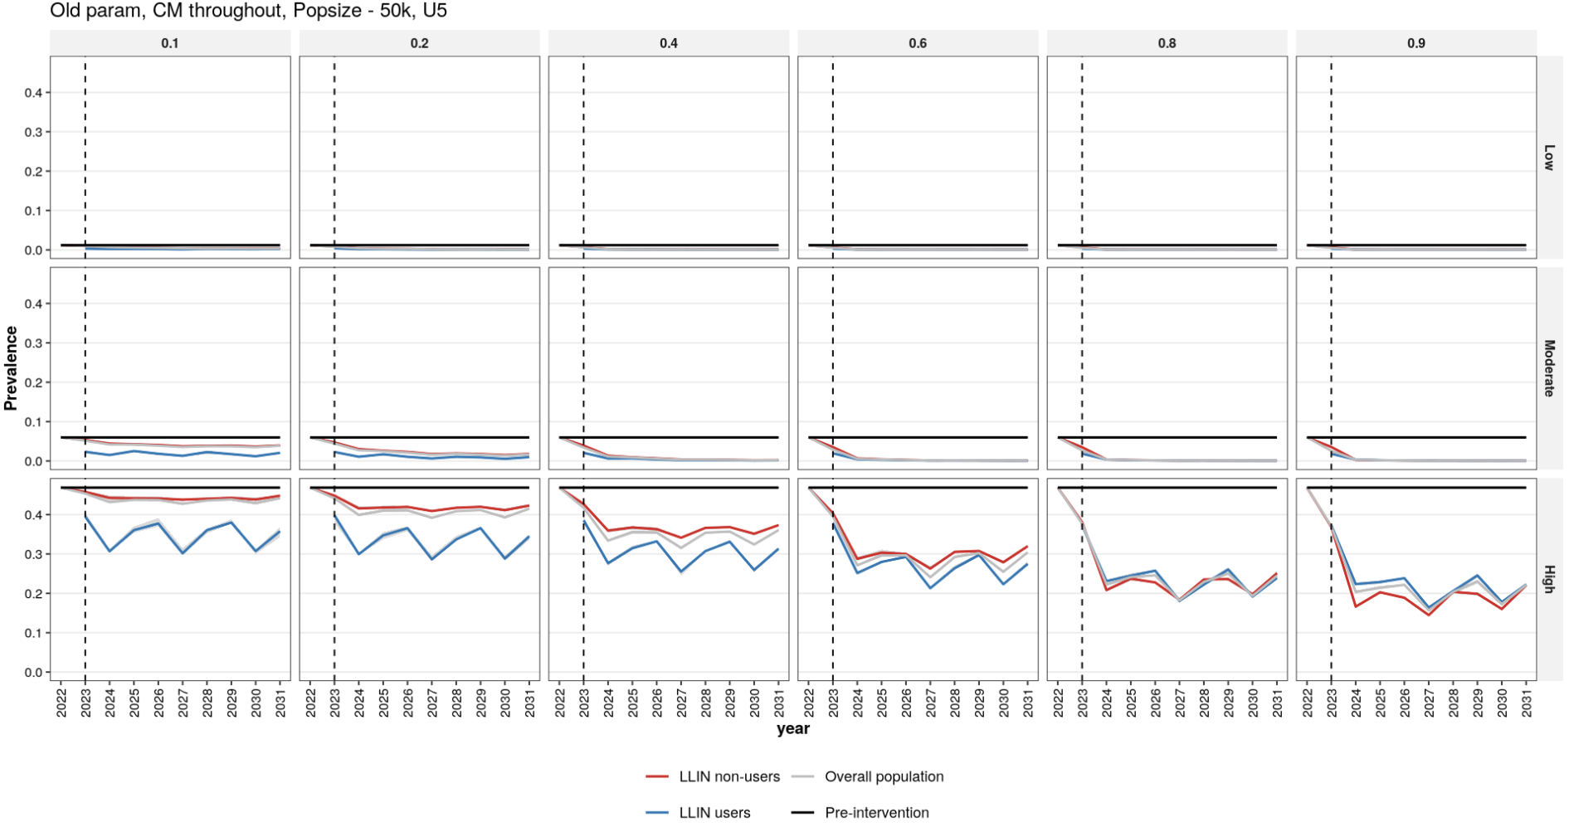

Update with new parameterization
